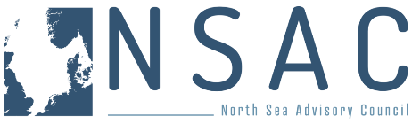**

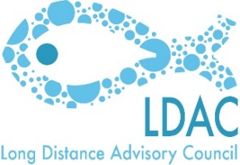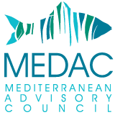



**AGENDA**

**Multi-AC workshop on the revised control regulation**

**Wednesday 05 February 2025**

**Albert-Borchette-Centre, AB-4B (RUE FROISSART 36), Brussels**

|  |  |
| --- | --- |
| **Horizontal Session with remote access (FR, DE, EN, IT, ES, PT)** | |
| **08:30 – 08:40** | **1** Welcome and introductions – tbc |
| **08:40 – 09:10** | **2** Presentation on the state of play of the implementation of the control regulation – Marta Moren-Abat, DG MARE |
| **09:10 – 10:00** | **3** Topics for discussion   * Clarifying Roles and Responsibilities: Who does what? * Remote Electronic Monitoring (REM): Define criteria for identifying "high-risk" vessels.   + ACs to provide their views if any   + Specify standardised technical requirements, equipment maintenance needs, and associated costs.   + Establish guidelines on data use, ownership and transmission protocols.   + Clarify accountability in cases of transmission errors versus fisher responsibility.   + Address monitoring approaches for vessels outside the mandatory CCTV scope as well as third-country vessels fishing in EU waters. * Electronic Logbook Submission: Establish requirements for completing and submitting electronic logbooks to ensure accuracy and compliance.   + Short introduction from COMM * Harmonization of Control and Enforcement: Standardize control activities, points system, and sanctions across Member States for consistent enforcement.   + ACs to provide their views, if any |
| **10:00 – 10:15** | **Coffee break** |
| **NWWAC/PelAC/NSAC/BSAC session – in person only (EN-FR-ES)** | |
| **10:15 – 12:30** | **1** Remote electronic monitoring   1. Consider EU standards versus third-country requirements and in particular UK-Scotland. |
| **2** Vessel Monitoring Systems (VMS) for Small-Scale Vessels   * COMM to provide brief introduction and reminding obligations under CR * Feedback from ACs, if any  1. Examine costs and explore affordable alternatives for small-scale operators. 2. Clarify accountability in cases of transmission errors versus fisher responsibility. 3. Propose a joint Member State (MS) system for streamlined VMS implementation. |
| 3 Weighing Procedures   * Commission to provide a brief introduction * Feedback from ACs, if any  1. Clarify and standardize weighing procedures across fisheries to maintain consistency. 2. Feasibility of sampling procedures for the weighing at landing of sorted fishery products that have already been weighed on board |
| **4** Review the practicality of the current Margin of Tolerance requirements   * COMM to provide a brief reminder of the revised CR on Article 14 (MoT) * ACs to provide their views if any |
| **5** Review the current requirements for a port to be listed as a Designated Port to avail of a derogation to the Margin or Tolerance rules.  ACs to provide their views, if any |
| **6** Monitoring Engine Power:   1. Define technical specifications, equipment and maintenance needs and associated costs. 2. Define criteria for identifying "high-risk" vessels. 3. Provide clear guidance on implementation and compliance.   ACs to provide their views, if any |
| **7** Use and opportunities of EMFAF and other funding opportunities if any. |
| **LDAC session (EN)** | |
| **12:30 – 13:00** | **1** Prior notification of landings in third countries (list of designated ports).   * ACs to provide their views, if any |
| **2** Fishing vessels other than catching vessels.   * ACs to provide their views, if any |
| **3** Transshipments outside EU waters and in non EU ports   * ACs to provide their views, if any |
| **4** Derogation of 20pc of Margin of Tolerance (MoT) for EU tropical tuna purse seine fleets on third country fishing ports.   * ACs to provide their views, if any |